MAD-1 Project Report – Campus Connect

- Student Details
Name: K R Vedhava Krishna
Roll Number: 22f3001228
Email: 22f3001268@ds.study.iitm.ac.in
About Me: I am a dual degree student pursuing my final year in B.Tech Smart Manufacturing from IIITDM Kancheepuram and also pursuing B.S Degree in Data Science and Application from IIT Madras. I love to challenge myself and love to play football.

Project Details

Project Title: Campus Connect - Placement Management System

Problem Statement:
Create a web-based Placement Management System that helps admins, Companies, and Students to manage the placement chaos in one place,by taking care of Company Registration, Selection of Students, Creation of Placement Drives using Flask, Jinja2, Bootstrap, HTML and SQLite.

Approach:
I approached the project by breaking the system down into its core needs: users, registrations, and creation of placement drives. From there, I built each feature
step-by-step, starting with database design, then role-based access, and finally connecting the front-end pages with the backend logic to create a smooth workflow for admins, Companies, and Students.

AI/LLM Declaration
I used Gemini 3.1 to assist with some of the code suggestions and ChatGPT-5 mainly for debugging and making the README.md documentation.

Category | MAD-1 Allowed % | My Usage %
Flask (App + API) | 20% | 18%
SQLite + SQLAlchemy | 15% | 10%
Bootstrap / CSS | 8% | 6%
Authentication | 10% | 6%
HTML + Jinja | 15% | 12%

Technologies and Frameworks Used

Technology / Library | Purpose
Flask | Core backend web framework
SQLAlchemy | ORM (Object Relational Mapper) for the SQLite database
Jinja2 | Template engine for rendering dynamic HTML pages
Bootstrap 5 | Used for Frontend styling and responsive design
werkzeuk | For generating and checking password hash
Flask-Login | Used for User authentication and session management
SQLite | Relational database management system (RDBMS)
Bootstrap Icons | Used the Icon library for user interface elements

- Database Schema / ER Diagram\

Tables:

Tables:

● User — stores user authentication and basic info
(id, username, email, password_hash, role, is_active)

● Company — stores company profile information
(id, user_id, name, hr_contact, website, is_approved)

● Student — stores student profile information
(id, user_id, name, contact, resume_file)

● Drive — stores placement drive details created by companies
(id, company_id, title, description, eligibility, deadline, status, created_at)

● Application — stores student applications for placement drives
(id, student_id, drive_id, status, application_date)

Relationships:

● One-to-One → User → Company
Each company account is linked to exactly one user.

● One-to-One → User → Student
Each student profile belongs to exactly one user.

● One-to-Many → Company → Drive
A company can create multiple placement drives.

● One-to-Many → Student → Application
A student can apply to multiple placement drives.

● One-to-Many → Drive → Application
A drive can receive applications from multiple students.

● Many-to-One → Application → Student
Each application belongs to a specific student.

● Many-to-One → Application → Drive
Each application corresponds to a specific placement drive.

● Unique Constraint → Student + Drive → Application
A student can apply to a particular drive only once.

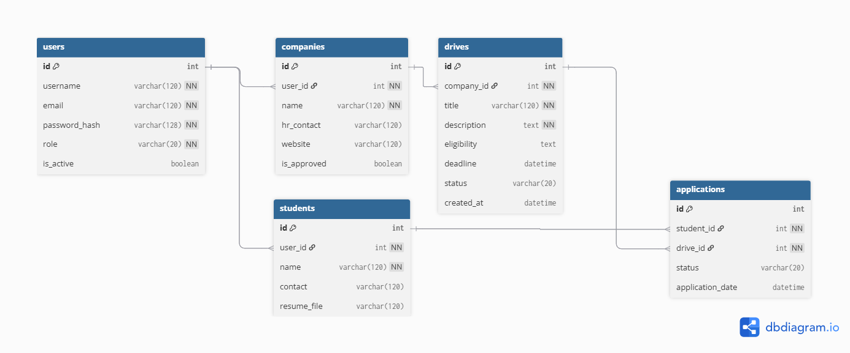

API Resource Endpoints
Here are some of the API endpoints -

Endpoint | Method | Description
/ | GET | Returns statistics for companies, drives, and placed students.
/register | GET | Used to Register a new user or Company based on role selected.
/student/apply/{drive_id} | GET | Apply to the Placement Drive.
/company/create_drive | GET | Creates a Placement drive for the Company
/company/drive/{drive_id} | POST | Used to View Application for a particular Placement Drive.

YAML API Definition File:
Included separately in the submission ZIP as api.yaml

Architecture and Features

run.py and system/init/py – Main Flask application entry point, configuration, and extensions setup (SQLAlchemy, Bcrypt, LoginManager).

system/models.py – Database schema and relationships using Flask-SQLAlchemy (User, Company, Student)

/routes – Application routing and role-based business logic (Authentication, Admin flows, Company operations, Student dashboard).

system/templates – Jinja2 HTML templates for dynamic page rendering (modularized via base.html).

system/static – CSS styling (main.css) and secure storage directory for uploaded assets (Student resumes).

Implemented Features:

- Role-based access control (Admin, Company, Student)
- User registration, secure login, and session management
- Company Registration and Placement Drive Creation
- Student Profile Management, Editing and Resume Uploading
- Admin dashboard for approval/rejection workflows (Companies and Drives) and user status control
- Responsive UI design using Bootstrap 5
- REST API endpoints for external integration
- Secure Password hashing using werkzeuk

Project Links

Drive Link:
Need to upload to videoooooooooooo

